**Our Strategic Priorities 2022-25:**

* **Curriculum, Learning & Teaching**

Promoting aspiration for all through inspiring learning experiences and ambitious pathways to success

* **Relationships**

Developing a supportive community with positive relationships for learning

* **Wellbeing**

Improving happiness, health and wellbeing for all in a safe, inclusive, mentally healthy school community

We are entering year 3 of our 2022-25 Strategic Plan. Significant progress has been made in some areas, with further development required in others. As expected, in responding to success and challenge, some priorities have shifted and some have been refined. In year 3, we had always planned for fewer actions within each key priority area as the foundations had been established over years 1 and 2. Evaluation will take place throughout the year to determine priorities beyond 2025.

**Our Vision:**

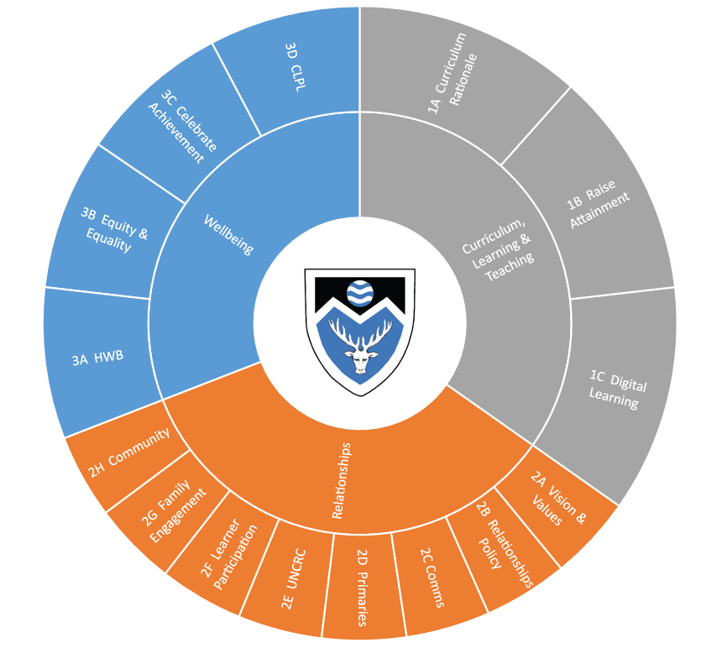We are preparing young people for success now and in the future by developing skills and values through inspiring learning and teaching in a nurturing and supportive environment.

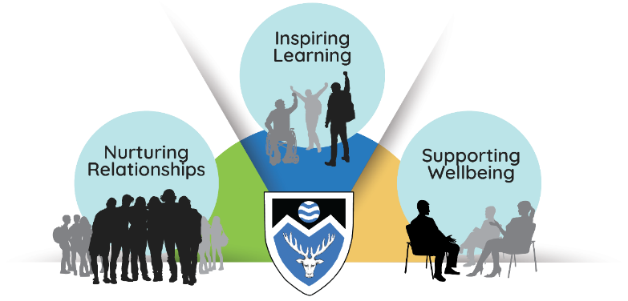

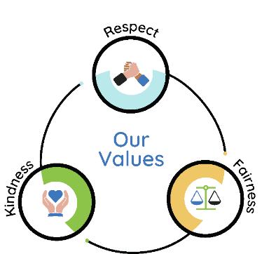 **Our Values**

**Our focus for improvement 2024-25:**

* Review our curriculum offer and continue to develop pathways for learners
* Roll out and embed the Relationships Policy, including enhanced understanding and development of school values
* Continue to develop moderation to support effective learning, teaching, assessment and reporting
* Improve approaches to differentiation and feedback to ensure young people know where they are in their learning and can determine their next steps
* Improve overall attainment in S6

**Key Improvement Priorities & Actions for Teaching Staff 2024-25**

The following actions are those within year 3 of the strategic plan that apply most directly to teachers and will be actioned through Curriculum Group Improvement plans.

|  |  |
| --- | --- |
| **Priority Action** | **Specific Action** |
| **1A - Curriculum Rationale** | * Review of curricular offer and progression pathways including opportunities for courses within level 3 and 4 * Develop profiling through S1-S2 * Continued development of inclusion of Learning for Sustainability in course planning (naturally emerging links) |
| **1B – Raise Attainment** | * Continued development of approaches to differentiation * Focus on LI/SC with link to Meta-skills and the use of plenaries to support learners to know where they are in their learning * Increase variation and quality of feedback and review the impact for learners * Review opportunities for learners to support planning and organisation of learning * Implementation of S1 Achievement of Level reporting & engagement with 2-18 tracking tool * Tracking utilised to identify early intervention for literacy, numeracy and curricular area support * Development of learning conversations to include target setting to support progression within the BGE * Refreshed approaches to moderation embedded within Curriculum Groups including use of ACEL data and Milestone data * Development of assessment to ensure learners can achieve at appropriate levels (including level 2) and judgments on levels are accurate |
| **1C – Digital Learning** | * Enhance Learning & Teaching by using Digital Learning to support learners experiences in line with 2.3 self-evaluation rubric * Departments will integrate digital technology across the curriculum and embed digital activities in S2 courses * Staff regularly signpost aspects of digital literacy in lessons * Continue development of digital approaches for formative and summative assessment and for providing feedback * Embed assistive technology tools to support inclusion * Class resources shared for all courses on GLOW via MS Teams and Sharepoint with increasing use of OneNote |
| **2B – Relationships Policy** | * All staff to implement, and operate in line with, Relationships Policy as part of The Monifieth Way |
| **2E – UNCRC** | * Further explicit links made within curriculum group plans where UNCRC naturally links for learning and teaching |
| **3B – Equality, Equity & Inclusion** | * Develop whole school understanding of wellbeing, including development of shared language in relation to GIRFEC and wellbeing indicators * Further embed planning for interventions at curriculum group level in response to TSG tracking and monitoring |
| **3D – CLPL** | * Undertake practitioner enquiry in relation to an aspect of learning and teaching |